Motion detection

- Implement a function that returns TRUE or FALSE for motion detected
- Implement a Buzzer that makes sound when motion is detected
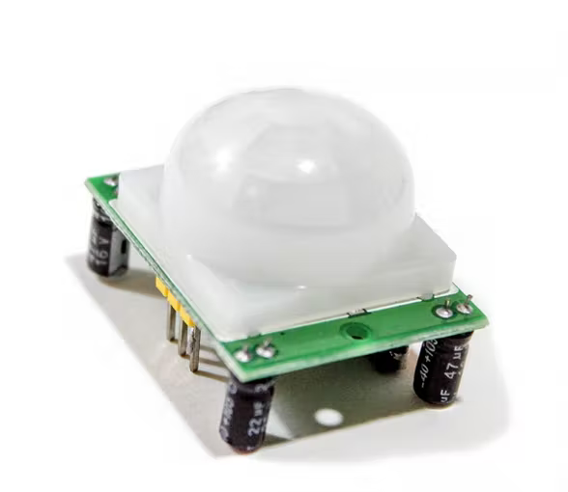
- Add 3 LEDs and booleans (also for debugging)
  - System armed ON/OFF (TRUE/FALSE)
  - Timer before alarm ON/OFF
  - Alarm/buzzer ON/OFF (TRUE/FALSE)
- Add 2 buttons
  - Simulating “correct password”
  - Arming the system

- Implement logic
  - Setup
    - System armed = FALSE
    - Buttons are inputs
    - LEDs as output
    - All LEDs are off
  - Loop
    - Check motion
    - If system armed = FALSE:
      - Buzzer = FALSE
      - Timer = FALSE
    - If system armed = FALSE AND arm_button = TRUE:
      - Armed = TRUE
    - If system armed = TRUE AND motion = TRUE AND timer = FALSE
      - Start timer
      - Timer LED = TRUE
    - While timer = TRUE:
      - If password_button = TRUE:
        - System armed = FALSE
        - Timer = FALSE
        - Break
      - If timer > 10 seconds:
        - Buzzer = TRUE

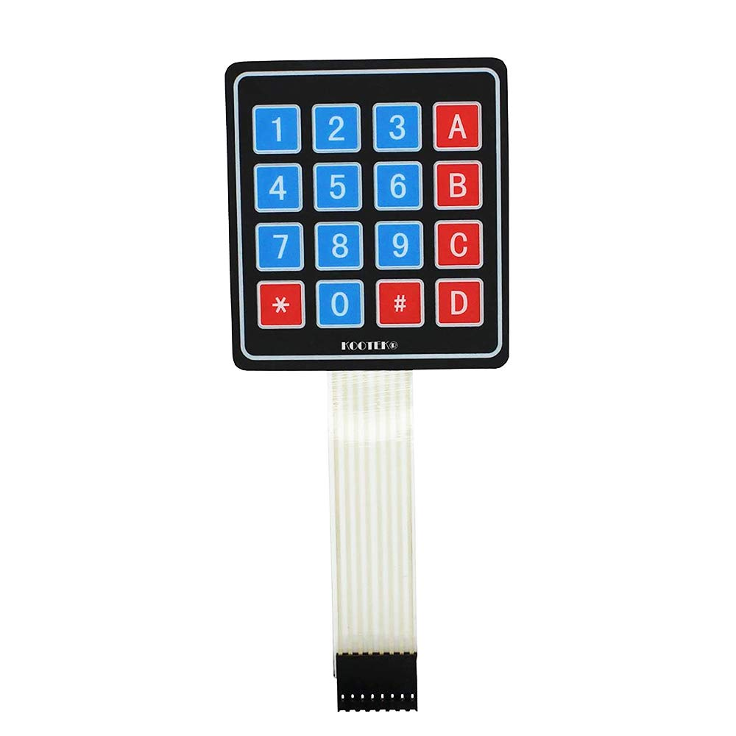
Keypad module
- Figure out what library to use
- Test the following individual buttons:
  - Buttons 0-9 prints its respective number
  - Submit button
  - Backspace button
- Buttons 0-9 and other buttons in combination are used to print a 4 digit number
- Add one LED for showing if the system is armed
- Implement logic
  - Setup
    - Buttons as inputs
    - LED as output
    - System armed = FALSE
    - Password string
  - Loop

    - Input = read_keypad()
    - If password == input:
      - Armed != armed (toggle armed)
      - armed_LED = armed
  - Int read_keypad()
    - Char input[4] = ””
    - While strlen(input) < 4:
      - If backspace is pressed:
        - Pop the last element from input[]
      - If 0-9 is pressed:
        - Print to console, debugging
        - Append to input[]
    - Return convert_to_int(input)

LCD

